## Web Technologies Lab Manual as per JNTUK-R16

### 3. CATALOGUE PAGE:

**EXPERIMENT-3**

The catalogue page should contain the details of all the books available in the web site in a table. The details should contain the following:

1. Snap shot of Cover Page.
2. Author Name.
3. Publisher.
4. Price.
5. Add to cart button.

### catalogue.html

<html>

<head>

</head>

<body>

<title> Catalogue Page</title>

<table width="100%" height="100%" border="1">

<tr>

</tr>

<tr>

</tr>

<tr>

</tr>

<tr>

</tr>

</table>

</body>

</html>

<td><img src="xmlb.gif" height="100" width="100"/></td>

<td>Book: XML Bible

<br>Author: Winston

<br>Publication: Wiely</td>

<td>$40.5</td>

<td><img src="adc.gif" height="100" width="100"/></td>

<td><img src="ai.gif" height="100" width="100"/></td>

<td>Book: AI

<br>Author: S.Russel

<br>Publication: Princeton hall</td>

<td>$63</td>

<td><img src="adc.gif" height="100" width="100"/></td>

<td><img src="java2.gif" height="100" width="100"/></td>

<td>Book: Java 2

<br>Author: Watston

<br>Publication: BPB publications</td>

<td>$35.5</td>

<td><img src="adc.gif" height="100" width="100"/></td>

<td><img src="html.gif" height="100" width="100"/></td>

<td>Book: HTML in 24 hours

<br>Author: Sam Peter

<br>Publication: Sam publications</td>

<td>$100</td>

<td><img src="adc.gif" height="100" width="100"/></td>



## Web Technologies Lab Manual as per JNTUK-R16

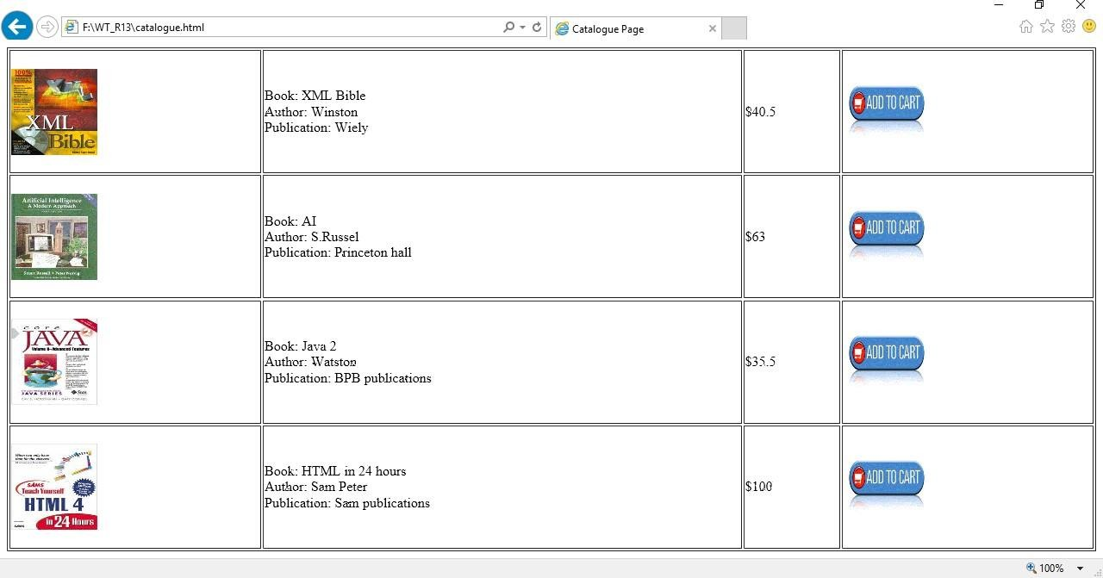

### OUTPUT: